**Sprint 3 - Agility**

**December 2020**

**Table of Contents**

1. **Executive Summary 3**
   1. Project Overview 3
   2. Purpose and Scope of this Specification 3
2. **Product/Service Description 3**
   1. Product Context 3
   2. User Characteristics 3
   3. Assumptions 3
   4. Constraints 3
   5. Dependencies 4
3. **Requirements 4**
   1. Functional Requirements 4
   2. Security 5
      1. *Protection 5*
      2. *Authorization and Authentication 5*
   3. Portability 5
4. **Requirements Confirmation/Stakeholder sign-off 5**
5. **System Design 6**
   1. Algorithm 6
   2. System Flow 6
   3. Software 6
   4. Hardware 6
   5. Test Plan 6
   6. Task List/Gantt Chart 6
   7. Staffing Plan 6

1. Executive Summary

1. ***Project Overview***

The objective of this project is to complete the intended Robot project with clear indications on sprints, accuracy and agility. The intended audience for this project is for CS104.

* 1. ***Purpose and Scope of this Specification***

The purpose of this specification is to allow people to use the robot where it is intended to be like on smooth surfaces. The audience for our product could be anything from children to adults, students and professors.

**In scope**

* The product is only meant to smooth surfaces

**Out of Scope**

* The product is not meant to be on uneven or loose surfaces such as carpets and sand
* The program will not be Endurance
* The program will not be Accuracy

1. Product/Service Description

In this section, describe the general factors that affect the product and its requirements. This section should contain background information, not state specific requirements (provide the reasons why certain specific requirements are later specified).

1. ***Product Context***

The product relates to the other two spirits like the agility test and endurance test . The product is not independent or self-contained because it needs to be programmed/coded and it needs to be tested. The product is completely useless on its own unless it is controlled by an outside source or another device. Yes the product does interact with a variety of systems. The systems include interacting with the Sphero app for coding and connecting to the app via bluetooth to control the robot.

1. ***User Characteristics***

* Student
* Classmates
* Professor
* Professionals
  1. ***Assumptions***

The availability of the Robot, We also assume that each user is competent in the field of software engineering, and there is also an assumption that syphero would be the operating system that an individual uses in order to make sure that robot meets the desired requirements for this project. In addition, the robot should work as intended, and there is an assumption that each group understands the necessary software to complete the robotics project. Finally, we as a group assumed that the physical conditions of Robot would be less taxing on the project. For example, for this portion of the project agility, Ryan had tested the robot in his garage. The garage was a smaller room than the room at Monmouth and the wear and tear of his garage included cracks and breaks in the floor.

* 1. ***Constraints***
* Syphero having an update that interferes with how the robot operates
* Measurement requirements may change
* Syphero requires the app be downloaded
* Physical locations the design needs to abide by may change
* One Member had access to the Robot
* Our group works part time/full time jobs
* Covid-19 Limited our opportunities to meet up with fellow group members
* The surfaces that the robot was tested was not smooth surface (it was in a cracked on concrete)
  1. ***Dependencies***
* Robot must follow the correct path or it will not succeed towards the intended path/goal
* Code must be established before project may begin
* The project is dependent on the robot following the correct course

1. Requirements

For this sprint, sprint 3 agility the requirements were not as concrete as the other sprints. To start our robot had to run the obstacle course created. The course will start in a square. Then will encounter three objects in which the robot must avoid. Next, the robot will go over the ramp. Finally, the robot will knock over as many pins as possible.

**Priority Definitions**

* Priority 1 - Robot will run an obstacle course
* Priority 2 - Robot will start in a square
* Priority 3 - Robot encounters obstacles
* Priority 4 - Robot will go over a ramp
* Priority 5 - Robot will knock over as many pins as possible upon coming down from the ramp

1. ***Functional Requirements***

|  |  |  |  |  |  |
| --- | --- | --- | --- | --- | --- |
| **Req#** | **Requirement** | **Comments** | **Priority** | **Date Rvwd** | **SME Reviewed / Approved** |
| AGIL-1 | Start in Square |  | Low | 12/1 | R/A  R/A  R/A |
| AGIL-2 | Avoid obstacles |  | High | 12/1 | R/A  R/A  R/A |
| AGIL-3 | Climb ramp |  | Low | 12/1 | R/A  R/A  R/A |
| AGIL-4 | Go down ramp |  | Low | 12/1 | R/A  R/A  R/A |
| AGIL-5 | Knock over as many pins as possible |  | High | 12/1 | R/A  R/A  R/A |

* 1. ***Security***
     1. **Protection**
* Collaboration on github
* Logging in and out of sphero
* Quality assurance tests
  1. **Authorization and Authentication**

This would be only allowing one member to access the robot. The single member with access to the robot will be able to input code needed for the navigation of the obstacle course. You can have access to the product via a username and password upon use.

* 1. ***Portability***

If portability is a requirement, specify attributes of the system that relate to the ease of porting the system to other host machines and/or operating systems. For example,

* Percentage of components with host-dependent code;
* Percentage of code that is host dependent;
* Use of a proven portable language;
* Use of a particular compiler or language subset;
* Use of a particular operating system;
* The need for environment-independence - the product must operate the same regardless of operating systems, networks, development or production environments.

1. Requirements Confirmation/Stakeholder sign-off

|  |  |  |
| --- | --- | --- |
| **Meeting Date** | **Attendees (name and role)** | **Comments** |
| 12/1 | Ryan (Tester) | All R/A |
| 12/1 | Evan (Organizer/design/scribe) | All R/A |
| 12/1 | Daniel (coder/scribe) | All R/A |

1. System Design

This section will provide all details concerning the technical design, staffing, coding, and testing the system

1. ***Algorithm***

* The robot must start in the square
* The robot must avoid three obstacles
* The robot must climb the ramp
* The robot must go down the ramp
* The robot must knock down as many pins as possible
  1. ***System Flow***

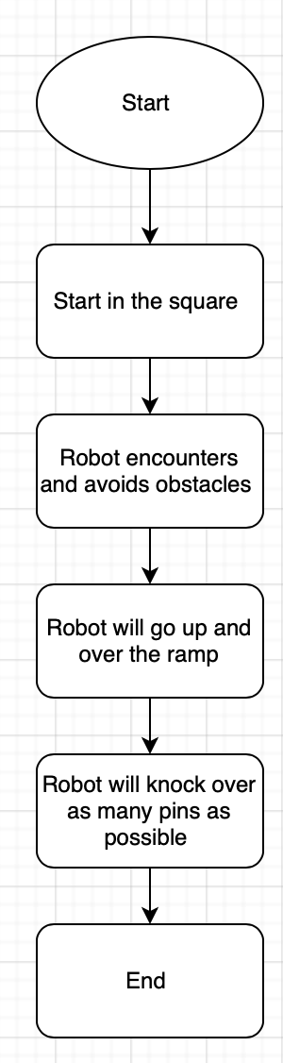

***3. Software***

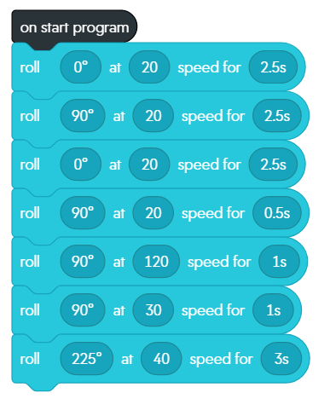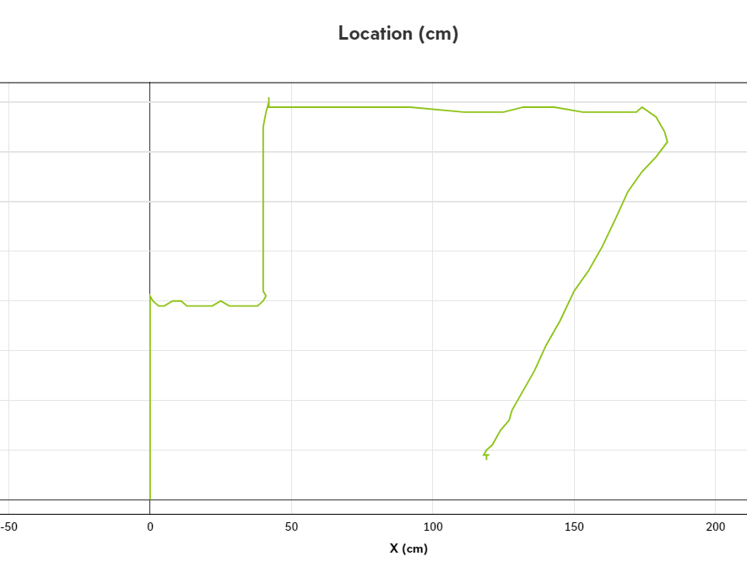

* 1. ***Hardware***

Describe hardware platforms that were used to develop, test and demonstrate this application

1. ***Test Plan***

Include a test plan showing all unit tests performed for this application, Include test rational, test date, staff member, pass/fail status

|  |  |  |  |  |  |
| --- | --- | --- | --- | --- | --- |
| **Reason for Test Case** | **Test Date** | **Expected Output** | **Observed Output** | **Staff Name** | **Pass/Fail** |
| Sphero must avoid obstacles | 12/13 | Sphero avoids obstacles | Sphero hit obstacle | Ryan | Fail |
| Sphero must avoid obstacles | 12/13 | Sphero avoids obstacles | Sphero avoided obstacles | Ryan | Pass |
| Sphero must go over ramp | 12/13 | Sphero clears ramp | Sphero missed ramp | Ryan | Fail |
| Sphero must go over ramp | 12/13 | Sphero clears ramp | Sphero did not make it over the ramp | Ryan | Fail |
| Sphero must go over ramp | 12/13 | Sphero clears ramp | Sphero made it over ramp | Ryan | Pass |
| Sphero must knock down all pins | 12/13 | Sphero knocks down all pins | Sphero missed pins completely | Ryan | Fail |
| Sphero must knock down all pins | 12/13 | Sphero knocks down all pins | Sphero knocked down half of pins | Ryan | Fail |
| Sphero must knock down all pins | 12/13 | Sphero knocks down all pins | Sphero knocked down all pins | Ryan | Pass |

* 1. ***Task List/Gantt Chart***

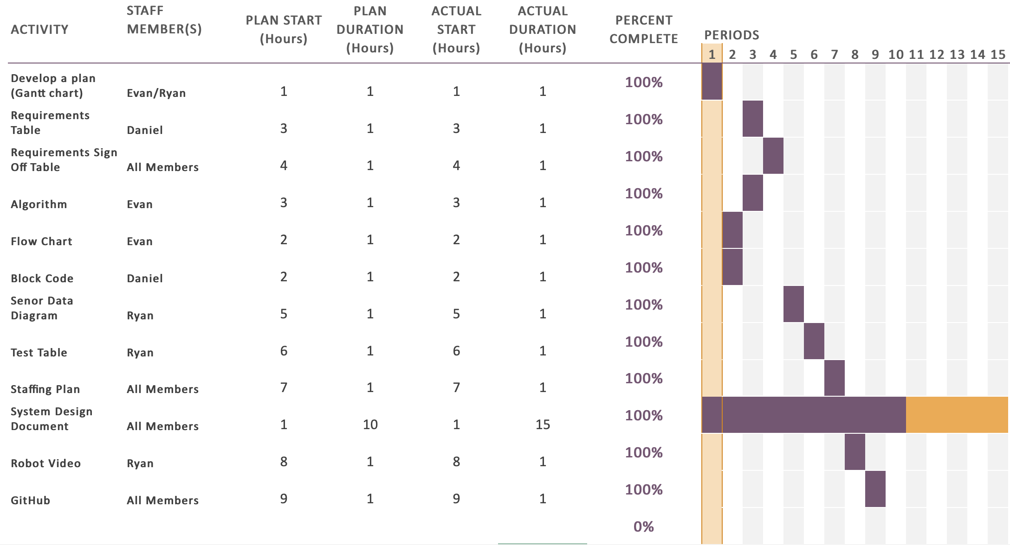

* 1. ***Staffing Plan***

Insert a chart/table that depicts the roles and responsibilities of each team member that worked on this project

|  |  |  |  |
| --- | --- | --- | --- |
| Name | Role | Responsibility | Reports To |
| Daniel | Group member | Coder/Scribe | N/A |
| Ryan | Handler of the Robot (testing) | Testing/Scribe | N/A |
| Evan | Group member | Organizer/Design/Scribe | N/A |